**OOMD LAB TEST – 1**

**Employee Recruitment System**

**ClassDiagram:**

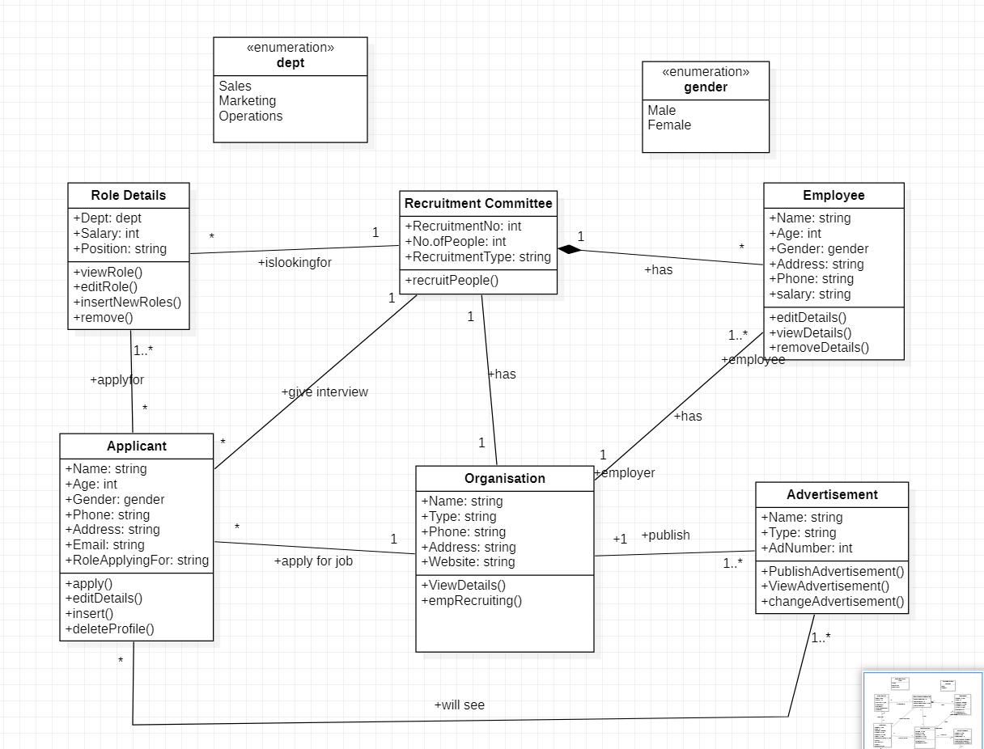

**State Diagram:**

